Analysis on the growth of Indian Startups

Final Project
Report
Of
Data Visualization
ISM6419.001S22
Prof. Han Reichgelt, PhD
University of South Florida

By

Uma Sankar Santhosh Koramutla
U00080441

Introduction:
India has become the third-largest startup ecosystem in the world after the US and China. A record of 44 Indian startups achieved unicorn status in 2021, taking the overall tally of startup unicorns in India to 83, with most of them in the services sector, the survey by Economic Times India showed. This survey added that 555 districts in India had at least one new startup, highlighting those startups in India have grown remarkably over the past six years, with most of them in the IT/knowledge-based sectors.
Few highlights of this survey are:
- There is an expectation to witness YoY growth of 10–12% in startup industry.
- 4 70 000 Jobs created by more than 39,000 startups.
- Startup jobs rose to 1.75 lakh in 2020 from 1.52 lakh in 2019.
- Due to an increase of active recognition of startups to 14,784 from 11,694 in the same period.
- More than 40 Startups are working in India's space sector.
*All these statistics were as of December 23, 2020
Minister for IT and Communications, India, Ashwini Vaishnav has said that in April-November 2021, India was raised Rs 89,066 crore through 75 IPO issues, much higher than in any year in the last decade. The Indian startup ecosystem has gained global recognition and respect, exhorting the startups and entrepreneurs to come out with inclusive new-age solutions to transform the lives of poor and marginalized sections.
By Considering all these factors, I thought that analyzing Indian startups and its funding would be quite interesting and useful.

Research Questions:
- How are the changes occurred in Startup Funding Ecosystem of India with respect to Time?
- What is the general cash flow or amount get by Startups in India?
- What are the top preferred industries or sectors among startups and in which cities they are?
- What is the importance of location in directing the Growth of a Startup?
- Who are the investors that play key role in Indian Startups Ecosystem?
- What are the different Types of Funding for Indian Startups?

References for the articles mentioned above:

https://economictimes.indiatimes.com/tech/startups/indian-startup-ecosystem-gains-global-recognition-ashwini-vaishnaw/articleshow/90978809.cms?utm_source=contentofinterest&utm_medium=text&utm_campaign=cppst

https://economictimes.indiatimes.com/tech/startups/what-economic-survey-2020-21-says-about-indias-startup-ecosystem/articleshow/80586774.cms

Methodology:

For this project, I have used two data sets. One is startup_funding which has the data about the Indian startups from year 2015 to 2020. Another is Indian startup funding 2021 which has the data about the information of startups in India for the year 2021. Both the data sets have been downloaded from Kaggle.
Links: https://www.kaggle.com/code/manisood001/indian-startup-funding-in-depth-analysis/data
https://www.kaggle.com/datasets/bhararthshiviah/indian-startups-2021

Both data sets have columns with the date in which startup founded, the location of the startup, Startup names, Industry or sector, sub-industry of that startup, the names of the investors, and the amount invested (in USD) and the year in which startup funded.

Analysis:

Changes in the Startup Funding Ecosystem:

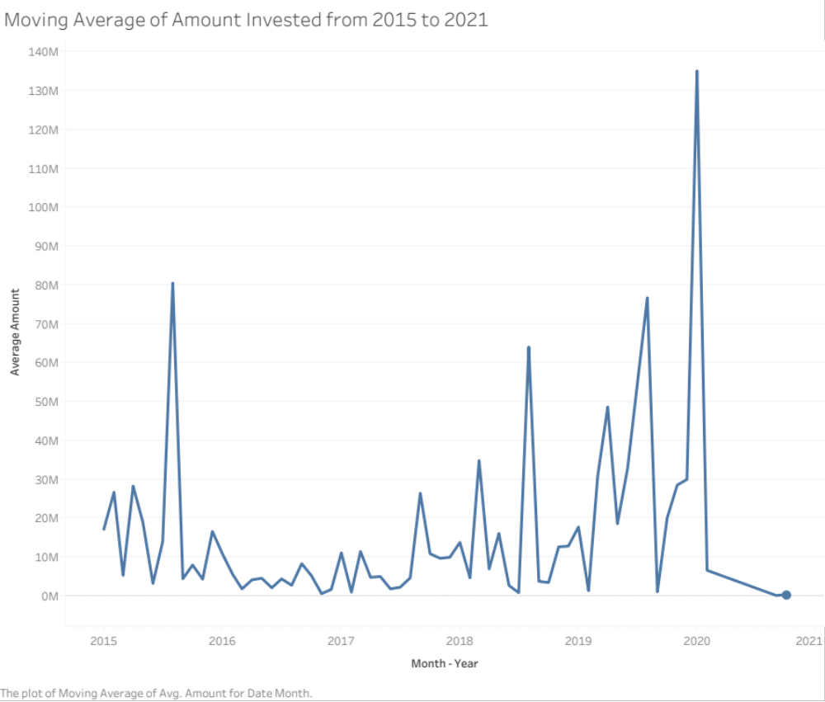
To know about the trend in investments of every year, I have used moving average to see trends.
The general cash flow or amount get by Startups in India every year:
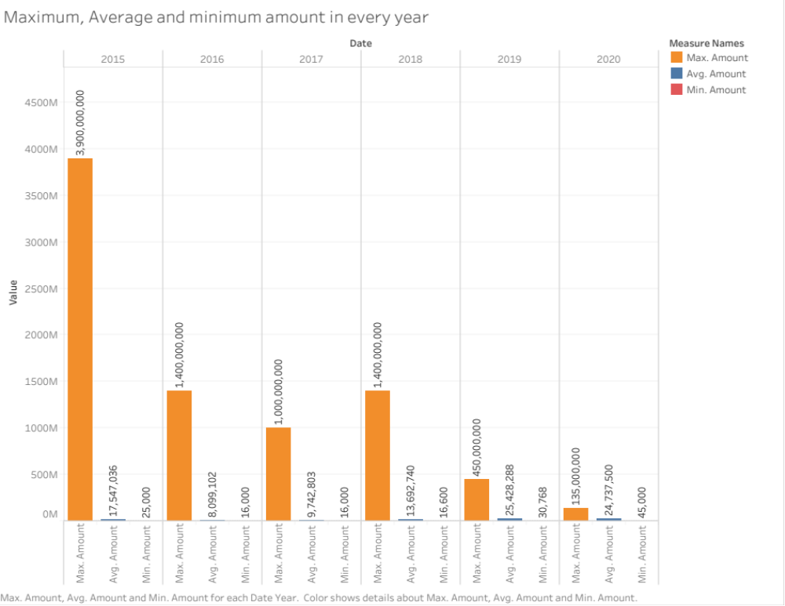

As the minimum, Average and maximum parameters give the insight of numbers, those functions have been used to know about the general cash flow in Indian startups.
What are the top preferred industries or sectors among startups and in which cities they are?

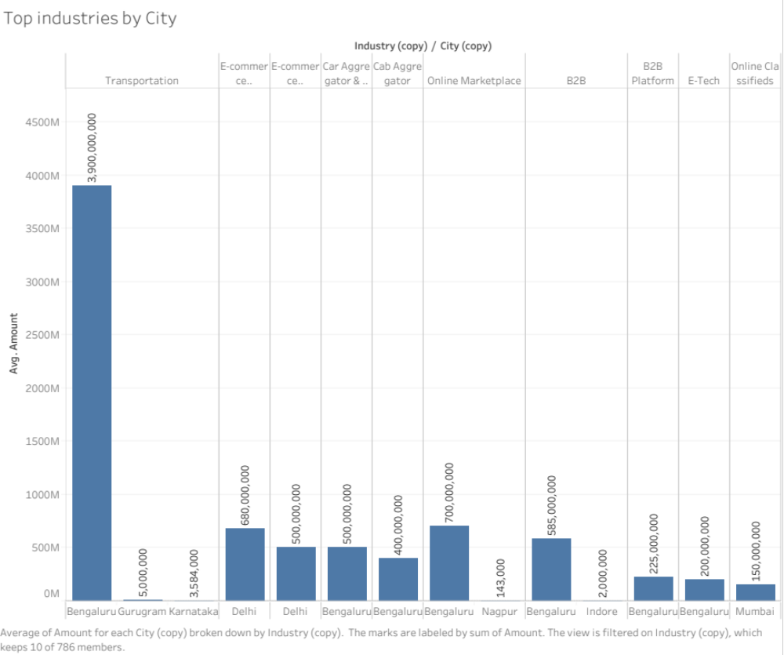

To know about the top industries which has high investments, I have used average of amount instead of Sum because the variable amount might have outliers which might give biased results.
What is the importance of location in directing the Growth of a Startup?

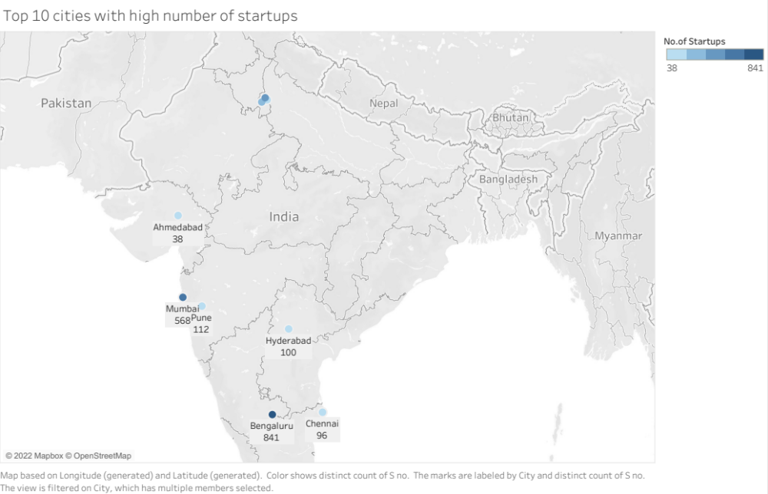

To know about the total startups, I have used count(s.no), where s.no represents unique value of a startup.

Who are the investors that play key role in Indian Startups Ecosystem?

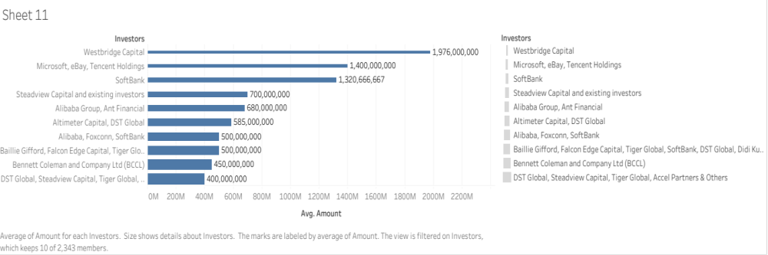

To know top investors, I have used average of amount and sorted it by Top Ten.

What are the different Types of Funding for Indian Startups?

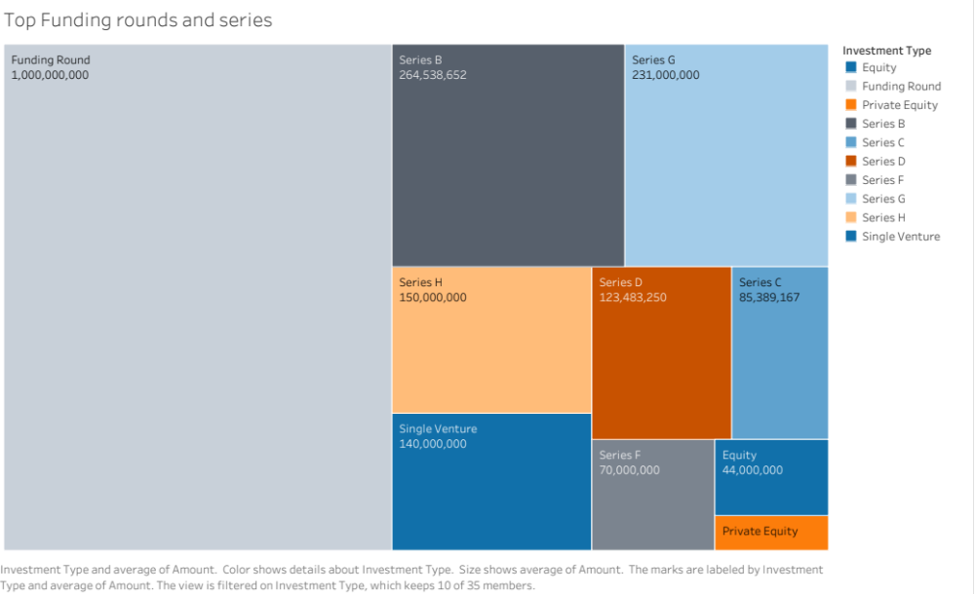

To know about top funding rounds, I have used average of Amount and filtered it by Top 10.

Conclusion:

- The Startup funding eco system of India changes in random manner. In the January 2015, the average investment amount is around 17 million USD, and it skyrocketed to almost 80 million USD in August. It dropped to as low as 1.7 million March 2016 and till February 2018 this low level continued varying from around 2 million to 20 million. In August 2018, it flies to around 60 million. Suddenly, in January 2020 it peaked to almost 130 million USD and by September 2020 it plummeted to less than a million it might be due to covid restrictions.
- In general, the year 2015 had highest maximum amount invested around 3.5 billion USD and lowest maximum amount invested is 135 million USD in the year 2020 but in the same year there had a highest average investment with 24 million USD in compared to year 2016 which had lowest average investment with 8 million USD. The Year 2020 had not only highest average amount invested but also it had highest minimum amount invested with 45000 USD whereas years 206,2017,2018 had lowest minimum amount invested which is about 16000 USD.
- Transportation industry had topped in investments with an amount of 3900 million USD which is the highest average amount among all the industries and this industry is flourished in Bangalore and Gurgaon. The rest of industries which are in top 10 in investments are E-commerce & M- Commerce platforms, E-commerce Marketplace, Car aggregator and retail mobile app, Car aggregator, Online marketplace, B2B, B2B platform, Ed-tech, Online class fields. Interestingly, most of these industries are in Bangalore.
- Location has a key role in the establishment of these startups. All the top 10 locations with most startups are cosmopolitan and metropolitan cities. National Capital Region (NCR (Delhi, Noida, Gurgaon)) had outperformed with a total of 880 startups in these years where as Bangalore, which is named as Silicon Valley of India, had given tough competition with 840 startups which is only 40 less than that of NCR had. Ahmedabad stood as top 10th city with 38 startups, which is one of the emerging economies of India.
- West bridge capital is the key investor in Indian startups which invested almost 1900 million USD followed by ﻿ DST Global, Steadview Capital, Tiger Global, Accel Partners, Bennett Coleman and Company Ltd (BCCL) , Alibaba, Foxconn, SoftBank , BaillieGifford, FalconEdgeCapital, Didi Kuaidi, Altimeter Capital, Ant Financial, Microsoft, eBay, Tencent Holdings. Among these Investors, DST capital, Alibaba, Tiger global and West bridge has multiple investments in various industries.
- Indian startups got most of the startups from Funding round which consists of almost 1 billion USD. Interestingly, Series A round doesn’t stand in top 10 in investments for startups but Series B, C, F, G, H had occupied in 2,7,6,3,4,8 places respectively. Equity and private equity rounds had also played a role in top investments.
- Internet consumer sector has most of the startups in India followed by technology and E-commerce and Finance.

Additional Research:

- Average number of startups had uptrend from 2015 to 2020 from 461 in 2015 to 3017 in 2020.

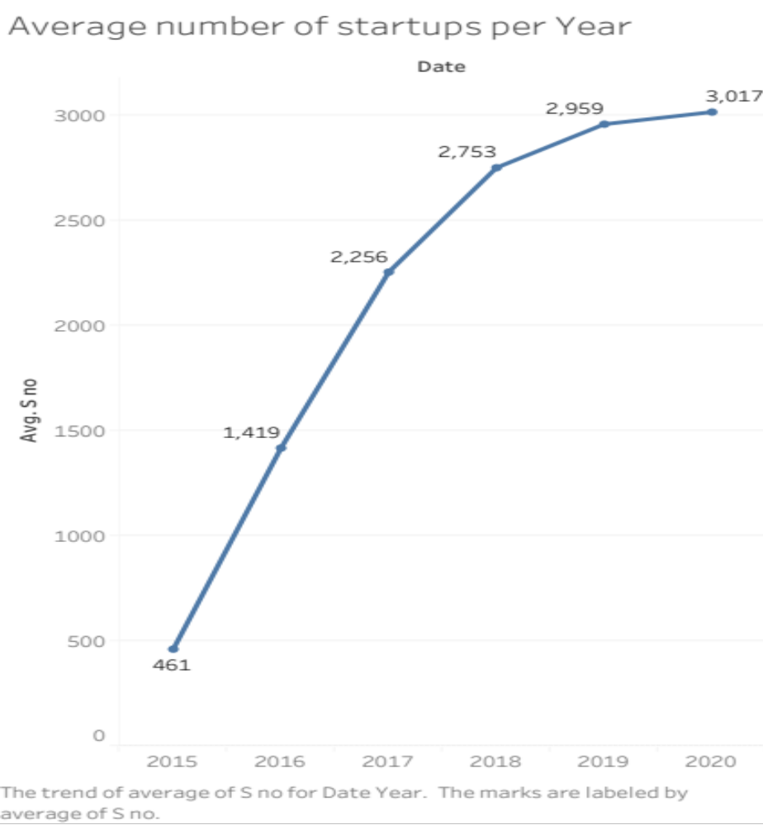

- E-commerce Industry had a big share of about 31% in total amount invested in startups in India whereas car aggregator had least share with 1.9% in total investment.

